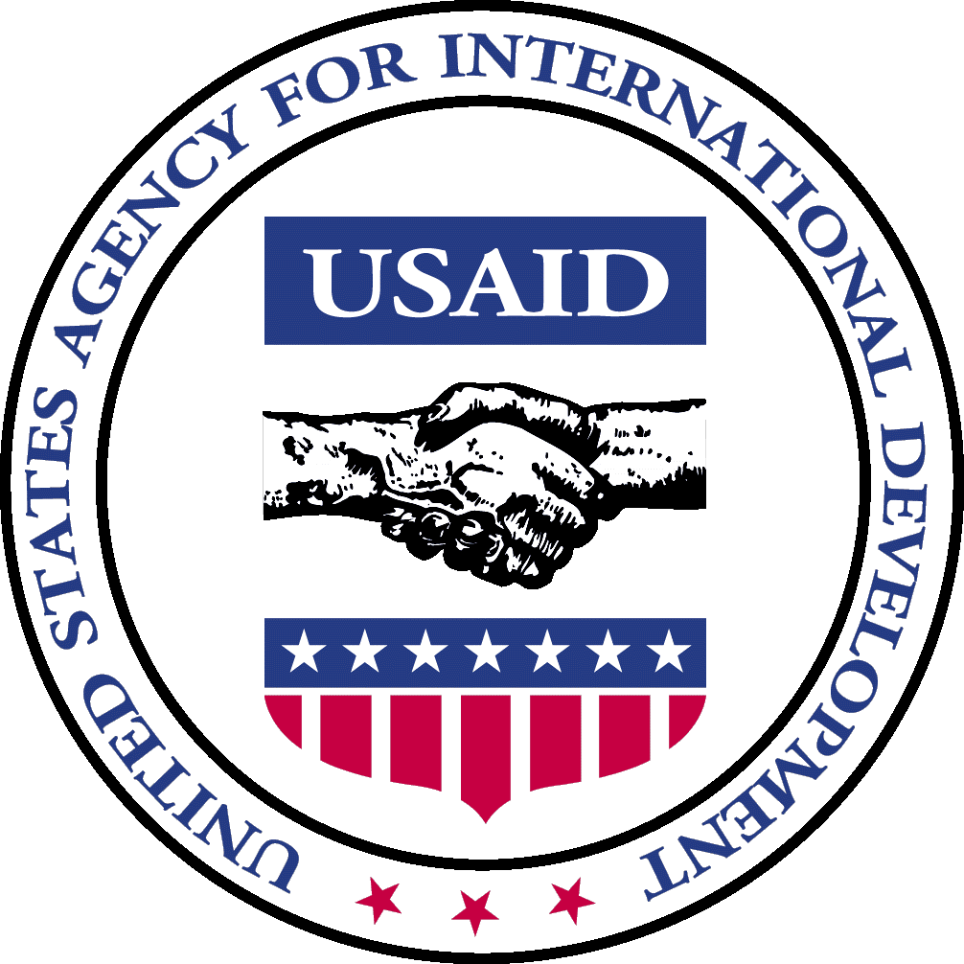

Office of Transition Initiatives
Bureau for Democracy, Conflict and Humanitarian Assistance

United States Agency for International Development

Hot Topic | BURUNDI | October 2004

OTI Media Partner Sparks National Leadership Response to Rumors of Violence in Kirundo

During October, an estimated 1,700 Tutsis in Kirundo fled to southern Rwanda after hearing rumors that their Hutu neighbors were planning massacres prior to the upcoming elections. Similarly, hundreds of Hutus took refuge in Tanzania, fearing that predominantly Hutu communities would be targeted by forces loyal to Tutsi groups. When personnel of OTI’s Community-based Peace and Reconciliation Initiative (CPRI) heard about these developments, they sent a media team to Kirundo to look into the rumors that had apparently helped cause them.

CPRI media partner, RSF Bonesha FM, broadcast interviews with Hutus and Tutsis in Kirundo on its newly created radio program “Kaze Dusubize Hamwe” (“Let us reconcile”). “Tutsi people are fleeing in the thousands. They are selling all their properties and heading en masse toward neighboring Rwanda,” one Hutu villager in Kirundo told a Bonesha journalist. “We want top authorities to come here and calm the situation before it is too late,” a young man stated. His appeal was echoed by many other interviewees.

After hearing Bonesha’s report, Burundian President, Domitien Ndayizeye, traveled to Kirundo to speak with people in the most affected communities. Soon after the President’s visit, Minister of Good Governance and leader of the ex-rebel CNDD-FDD group, Pierre Nkurunziza, went to Kirundo, which is his home province, and urged people to return. The Deputy Army Chief of Staff, Brigadier General Adolphe Nshimirimana, also spoke with communities in Kirundo and dispelled rumors of ethnically motivated attacks. Several days after these high-level government officials’ visits, people began to return to their homes.

In supporting dissemination of accurate information and encouraging government leaders to respond to volatile developments throughout the country, CPRI is working to diffuse potential conflict situations. During the current pre-election period, which has been extended through April 2005, CPRI’s media partners have increased outreach trips to rural areas and have similarly increased their hours of broadcasting. In addition to media, CPRI program components include a Community-based Leadership Program (CBLP), vocational skills training (VST), and community initiatives. CPRI partners include PADCO, Inc., the Woodrow Wilson International Center for Scholars (WWICS) and African Strategic Impact (ASI).

For more information, visit our website at: http://www.usaid.gov key word – “OTI”

