Transition Initiatives | Burundi Monthly Report | February 2005

PROGRAM DESCRIPTION

The Office of Transition Initiatives (OTI) supports the ongoing peace process in Burundi as outlined in the Arusha Peace and Reconciliation Agreement (APRA) by strengthening local capacities to benefit from and contribute to the peace process. PADCO, Inc., the Woodrow Wilson International Center for Scholars (WWICS) and the national NGO African Strategic Impact (ASI) implement OTI’s Community-based Peace and Reconciliation Initiative (CPRI) and manage CPRI’s field offices in the provinces of Gitega and Ruyigi. Through CPRI’s four components: the Community-based Leadership Program (CBLP), vocational skills training (VST), community initiatives and media, the program strengthens local-level cooperation for conflict mitigation, helps diverse groups generate non-farm income, and increases knowledge and participation in public dialogue on current issues. The program engages community groups, government entities, media outlets, NGOs, international organizations and other USAID offices to maximize the positive outcomes of these efforts. Since February 2004, OTI has invested $3,943,609 in these activities through 171 small grants.

COUNTRY SITUATION

Electoral Code of Conduct Introduced – The Minster of the Interior made public the code of conduct to which Burundi’s political parties have agreed to adhere during the period of the constitutional referendum and elections. According to the code, the political parties will peacefully manage conflicts that might arise as a result of electoral competition. The draft electoral code was in part an outcome of a CPRI grant to the Burundi Leadership Training Program (BLTP), which organized an October 2004 workshop for the top leadership of 31 of Burundi’s then 33 political parties.

Ex-rebel Leader Returns from Exile – Former rebel leader and founder of the National Council for the Defense of Democracy - Forces for Defense of Democracy (CNDD-FDD), Leonard Nyangoma, returned to Burundi on February 12 after ten years in exile. At a news conference in Bujumbura upon his arrival, Nyangoma remarked that Burundi had taken a “significant step” toward democracy as it prepares for elections and reorganizes the national defense force to incorporate former rebel combatants.

Media Agencies Resume Operation – The privately owned Radio Public Africaine (RPA) resumed broadcasting on February 14, 48 hours after Burundi's National Communication Council (NCC) suspended its operations, accusing it of slander. Citing defamation, the NCC also ordered the private news agency, Net-Press, to close for seven days.

Post-transition Constitutional Referendum Held – The thrice-postponed national referendum on the draft post-transitional constitution took place on February 28 under optimal security conditions. The Vice-President of Burundi’s National Independent Electoral Commission (CENI) announced that provisional results indicate over 90 per cent of voters voted in favor of the post-transition constitution.

PROGRAM UPDATE

A. Narrative Summary

In February, OTI approved two grants totaling $3,020, bringing the total number of grants approved to 171 and total funds committed to $3,943,609 since February 2004. Media partner Burundi National Radio and Television (RTNB) received funding to broadcast innovative radio and television programs explaining the electoral process and the content of the draft post-transition constitution, the electoral code and communal law. By incorporating civic education messages into slogans, dramas and regular series, RTNB programming will reach illiterate populations and will increase the citizenry’s role in advancing democratic processes.

WWICS’ CBLP Lead Facilitator was in Burundi during February for three CBLP activities. She led a training-of-trainers workshop for the newly selected CBLP community facilitators, who, as permanent residents within their communes, support the Master Trainers in their work. Together with PADCO CBLP Coordinator, she observed and evaluated the work of eight Master Trainers in Gitega and Ruyigi. Together with PADCO CBLP Coordinator and ASI Director, Deputy Director and provincial CBLP coordinators, she planned a follow-up training for Master Trainers for early March. Discussions of Master Trainers’ experiences to date and anticipated changes in the political environment will help CBLP shift its approach as necessary for the second year of the program.

In February, CPRI celebrated the graduation of four groups of CBLP trainees, three in Gitega and one in Ruyigi. Hundreds of people, including provincial and local government officials, attended the celebrations, which were broadcast nationally by CPRI's media partner RTNB. The trainees, who themselves include local government officials and traditional leaders, attest that they are now better equipped to help their communities resolve conflicts peacefully. CBLP graduates receive laminated certificates and summaries of the CBLP curriculum, along with t-shirts with a CBLP slogan and umbrellas, to remind them of what they learned, grant them credibility within their communities, and facilitate their conflict-mitigation efforts. Because CBLP has Master Trainers present in every commune in Gitega and Ruyigi, it, unlike other leadership and conflict mitigation training programs, is able to reach remote communities that have not benefited from other outside interventions.

Communities in Ruyigi celebrated the graduation of students from CPRI-sponsored vocational skills training (VST) schools at Muriza, Bwagariza, Kinyinya and Gisuru. The Governor of Ruyigi, Gisuru’s Communal Administrator, and the province’s Director of Education attended the ceremony in Gisuru, where they used the event to express their appreciation for CPRI’s contribution to peace and recovery in Ruyigi, and to urge the population of Gisuru to take advantage of the vocational skills school to rebuild their commune and promote its economic development.
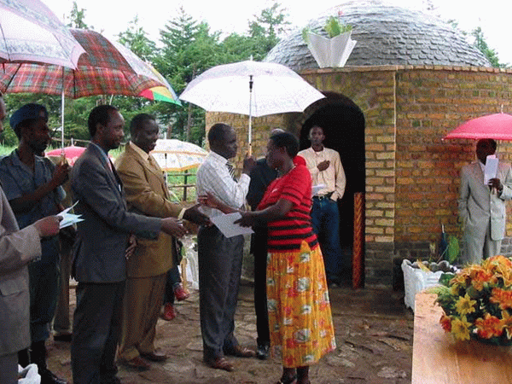
The Minister of Handicrafts, Vocational Training and Adult Literacy and members of the NGO community participated in the graduation ceremony at Muriza center, Butaganzwa commune. OTI media partners Burundi National Radio and Television (RTNB) and RSF Bonesha FM broadcast interviews with graduates, community members, local administrative officials and VST school staff and highlighted the Minister’s remarks. In addressing demobilized soldiers and ex-rebels, who represent 35 percent of the Ruyigi graduates, the Minister remarked that CPRI had transformed former combatants into productive, skilled citizens. He challenged the group to become messengers for peace and development in their communities. Large numbers of ex-combatants are enrolled in the Ruyigi schools’ second session.
Muriza VST students received skill-training certificates certified by the Ministry of Handicrafts, Vocational Training and Adult Literacy.
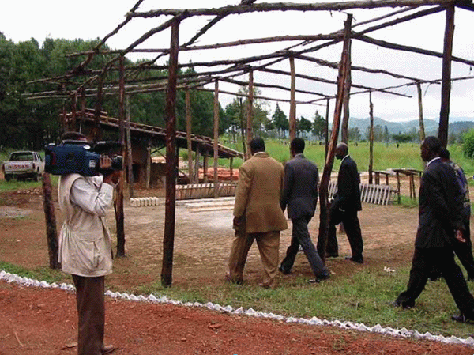
CPRI media partner RTNB televised Muriza vocational school’s graduation ceremony in Bwagariza commune, Ruyigi.
Recognizing CPRI’s broad reach in Gitega and Ruyigi, FAO plans to give CPRI’s VST component 120,000 trees to plant near each of CPRI’s eight VST schools for a total of 960,000 new trees. VST has already received and planted 80,000 trees: 10,000 at each of the eight schools.

OTI Acting Country Representative and the PADCO Chief of Party met with an official from the World Bank-funded Multicountry Demobilization and Reintegration Program (MDRP) to discuss ways to strengthen the linkages between the two programs and make CPRI increasingly responsive to the needs of recently demobilized ex-combatants. This meeting lay the groundwork for a potential future replication of CPRI’s efforts.

B. Grants Activity Summary

Program Category | # of Grants, Feb. 2005 | Funds  Obligated, Feb. 2005 | Total # of Grants to Date | Total Funds  Obligated to Date
Strengthened local-level cooperation for conflict mitigation | 1 | $2,239 | 83 | $1,842,855
Diverse groups generate non-farm income | 0 | 0 | 52 | $1,410,003
Increased knowledge and participation in public dialogue on current issues | 1 | $781 | 36 | $690,751
Total | 2 | $3,020 | 171 | $3,943,609

- Indicators of Success

Participants in CPRI Community Initiatives are beginning to organize themselves and voice their opinions in the interest of their communities. In an unprecedented act, Mugera residents in Bugendana commune, Gitega, came together to identify and peacefully resolve a minor theft of cement at the CPRI-funded Mugera Community Center project. The community now works together as an integrated unit and has vowed to keep corruption out of their community initiatives. CPRI has awarded three grants totaling $61,334 to Mugera to construct a community center, support reconciliation of diverse groups of people through sports and culture, and provide materials to an income-generating initiative of tailors.

CPRI celebrated the completion of the construction of a new primary school in Gisuru commune, Ruyigi. Hundreds of people, including the Communal Administrator and the Director of Education for Ruyigi, attended the celebration. RTNB internal performance monitoring reports indicate that listeners, particularly in Gitega and Ruyigi, express high interest in programs produced in collaboration with CPRI that explain the content of the draft post-transition constitution and their civil rights in practical terms.

The first graduates of the CPRI-supported VST schools are already in high demand for income-generating and reconstruction activities. The U.N. Operation in Burundi (UNOB), the Buyoya Foundation and GTZ have approached CPRI’s VST schools to ask that VST schools and graduates provide 8,000 desks for primary schools throughout Ruyigi; provide technical training to other Burundians through VST graduates, thus greatly multiplying VST's reach; and rehabilitate social infrastructure. Recent graduates from Gisuru VST are working with two local NGOs, supported by UNHCR and Caritas, to build eight houses and provide 200 doors and 400 windows for 200 more houses. They have also completed work commissioned by Gisuru's residents to repair a number of houses.

The VST program component is opening kiosks in Gisuru and Ruyigi center, Ruyigi to sell products emerging from VST sewing, furniture-making and bread-making classes. Already, people are traveling from Tanzania to the Gisuru VST school to purchase the bread being made there, since demand far outweighs supply in the region. The Governor of Ruyigi, impressed by the quality of work being produced at the VST schools, ordered doors for his new home from the VST school in Muriza, Ruyigi.

NEXT STEPS/PRIORITIES

CPRI is reevaluating its activities to ensure their responsiveness to the evolving political environment. CPRI is prioritizing outreach to other donors as part of its handover plan development.

Point of Contact:
In Washington, D.C.: Carlisle J. Levine, Program Manager, e-mail: clevine@usaid.gov , telephone: 202-712-0955
Visit the OTI website at: http://www.usaid.gov , Key Word “OTI”

