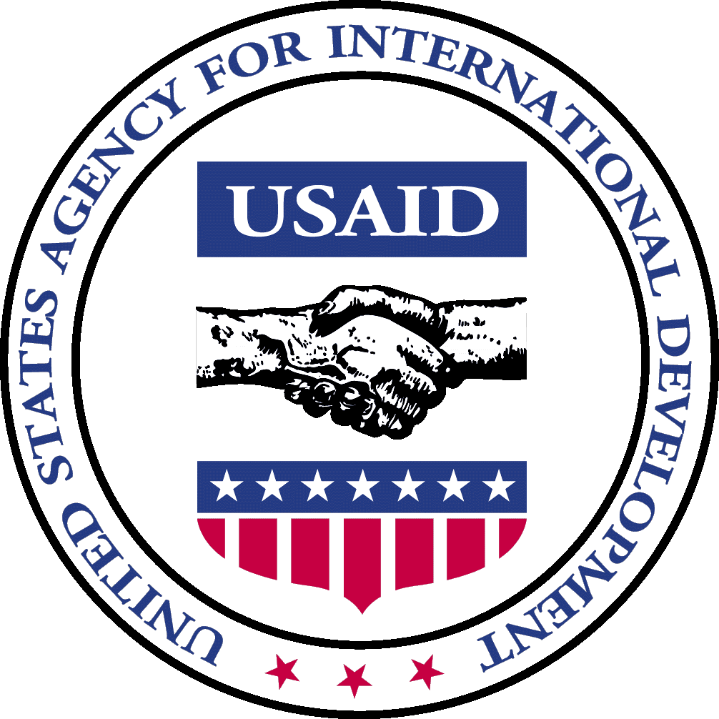

Office of Transition Initiatives
Bureau for Democracy, Conflict and Humanitarian Assistance

United States Agency for International Development

Monthly Report | BURUNDI | October 2004

PROGRAM DESCRIPTION

The Office of Transition Initiatives (OTI) supports the ongoing peace process in Burundi as outlined in the Arusha Peace and Reconciliation Agreement (APRA) by strengthening local capacities to benefit from and contribute to the peace process. PADCO, Inc., the Woodrow Wilson International Center for Scholars (WWICS) and the national NGO African Strategic Impact (ASI) implement OTI’s Community-based Peace and Reconciliation Initiative (CPRI) and manage CPRI’s field offices in the provinces of Gitega and Ruyigi. Through CPRI’s four components: the Community-based Leadership Program (CBLP), vocational skills training (VST), community initiatives and media, the four organizations encourage local-level cooperation for mutual problem solving, generation of new non-farm income, and dissemination of timely and balanced information that encourages broad participation in discussions related to the peace process. The four organizations work closely with community groups, government entities, media outlets, NGOs, international organizations and other USAID offices to maximize the positive outcomes of their efforts. Since February 2004, OTI has invested $2,964,813 in these activities through 133 small grants.

COUNTRY SITUATION

Regional Leaders Endorse Six-Month Extension of Transitional Government – Regional leaders attending an October 15 summit in Nairobi of the Great Lakes Initiative on Burundi, endorsed an extension of the transition period for six months and a revised electoral scheduled published by Burundi’s National Independent Electoral Commission (CENI).

Interim Constitution Signed – Burundi’s President, Domitien Ndayizeye, signed into law an interim constitution after it was endorsed by a special joint session of the National Assembly and Senate on October 20. The constitution, the same version that the Parliament adopted on September 17, extends the transitional institutions and administration. It will take effect at the end of Burundi’s three-year transition period on November 1 and will remain in place until the country adopts a post-transition constitution.

Post-transition Constitutional Referendum Postponed until November 26, 2004 – President Ndayizeye postponed a national referendum on the draft constitution initially scheduled for October 20 until November 26. CENI Chairman, Paul Ngarambe, explained that the referendum was delayed to allow time to conduct a national census and to register eligible voters.

Elections Scheduled for 2005 – The CENI issued a tentative elections schedule for 2005: hillside level on February 9; communal on February 23; legislative on March 9; senatorial on March 23; and presidential (indirect) on April 22. The CENI Chairman announced that the calendar could change again subject to availability of funds and security conditions.

Burundians Commemorate Assassinated Leaders – On October 13, Burundians commemorated the 43rd anniversary of the assassination of Prince Louis Rwagasore, founder of the Union for National Progress (UPRONA) political party. Rwagasore is widely considered to be the hero of Burundi’s independence from Belgium in 1962. October 21 marked the 11th anniversary of the assassination of President Melchior Ndadaye, who won the country’s first presidential elections held in 1993. The death of Ndadaye, Burundi’s first Hutu president, marked the beginning of Burundi’s now 11-year-old civil conflict.

PROGRAM UPDATE

A. Narrative Summary

In October, the WWICS trainer returned to Burundi to lead the CBLP Master Trainers in their second training. Discussions included strategies for following up with leaders already trained, identifying community facilitators, and recruiting civil society leaders with the potential to contribute to their communities.

On October 12, the U.S. Ambassador, James Yellin, presented media broadcasting equipment on behalf of USAID/OTI to Minister of Communications Onesime Nduwimana, who accepted the donation on behalf of CPRI media partner, state-funded Burundi National Radio and Television (RTNB). CPRI donated audiovisual analog/digital consoles, editing and mixing units, computers and software, digital cameras, and video monitors. Minister of Communications Nduwimana remarked that wider dissemination and better sound quality of news programs will better inform Burundians regarding the electoral process and help them more freely express their views on current events. On October 29, Ambassador Yellin presented broadcasting equipment to CPRI media partner, independent media outlet RSF Bonesha FM (Bonesha). Bonesha’s director credited CPRI-supported media outreach activities with “bringing a long lasting peace to Burundians, so that together they can work and devote themselves to finding solutions to socio-economic problems that they individually and collectively face”. Since February 2004, CPRI has provided $602,770 through 25 grants for broadcasting equipment and support for coverage of local, national and regional events that affect the peace process.

Another October highlight was a visit to CPRI project sites in Gitega province by a U.S. Embassy delegation. The group toured CPRI’s vocational skills training school in Giheta commune and met with community participants involved in the Giheta secondary school rehabilitation project and the Giheta Youth Initiative. The projects in Giheta are examples of how community initiatives succeed in bringing ex-combatants, refugees, displaced persons and others together to foster long-term reconciliation.

In October, CPRI approved 30 grants totaling $390,294. CPRI awarded grants that will respond to recent political developments, namely the extension of the transition period and adoption of a new electoral calendar. These grants will provide civic education on electoral processes and support peace initiatives.

CPRI awarded a grant to the Burundi Leadership Training Program (BLTP) to conduct a workshop for the top leadership of all 30 political parties that will participate in the upcoming elections. In the workshop, leaders will strengthen their abilities to communicate, negotiate and collectively resolve problems that might emerge during the election cycle including the relationship of elections to political democracy, the electoral law, the candidate code of conduct, political party management, methods of reaching out to constituencies and election-day procedures.

When USAID Administrator, Andrew Natsios, visited Burundi in September, he encouraged religiously affiliated organizations to play a significant role in peacemaking during the political transition period. In October, CPRI awarded a grant to provide a forum for church leaders from parishes throughout Burundi, as well as representatives from parishes in Rwanda and South Africa. During the forum, church leaders developed action plans to spread peace messages throughout the country during this period when tensions are expected to remain high due to ongoing political uncertainties.

CPRI is reinforcing links between program components in order to most effectively minimize peoples’ fears of possible violence surrounding the upcoming elections in 2005. The Community Initiatives team, the Media team, the CBLP Master Trainers and newly trained civil society leaders have joined efforts to quell people’s fears and create opportunities for open dialogue through informal community meetings. CPRI is complementing these efforts with support for community initiatives. For example, CPRI awarded a grant to the Benindanga Dancers Association, which uses dance and drama as a catalyst for positive interaction among divided groups. In Burundi, drama has proven an effective tool for encouraging communities in conflict to voice their concerns on sensitive issues.

Similarly, CPRI targeted support to three peace initiatives in Gishubi commune, Gitega, which has registered the highest number of youth combatants who have voluntarily demobilized. Communities in Gishubi are committed to resolving the challenges of reconciling ex-combatants who are reintegrating into civilian life, people living in internally displaced (IDP) camps and those who remained in their homes during the crisis. CPRI is working with communities to construct a center to revitalize sports and cultural events, specifically targeting youth ex-combatants. CPRI is also supporting community efforts to revitalize a community center, which they view as a symbol of peace returning to Gishubi. The center’s co-presidency, which is shared between a Hutu and a Tutsi community member, is already establishing a bridge between these two ethnically divided groups.

In October, a USAID Office for Private Voluntary Cooperation (PVC) representative met with USAID partners to discuss strategies for strengthening the NGO sector in Burundi. The USAID partners included CPRI’s ASI and PADCO, Africare, World Relief and Global Rights.

Grants Activity Summary

Program Category | # of Grants, Oct. 2004 | Funds Obligated, Oct. 2004 | Total # of Grants to Date | Total Funds Obligated to Date
Increased local-level cooperation for mutual problem solving | 23 | $306,824 | 75 | $1,469,256
Generation of new non-farm income by diverse groups | 7 | $83,470 | 33 | $892,787
Public knowledge of current issues increased as a result of media coverage |  |  | 25 | $602,770
Total | 30 | $390,294 | 133 | $2,964,813

- Indicators of Success

Thousands of Burundians in the northern province of Kirundo fled to Rwanda and Tanzania in October following rumors of imminent violence should elections be delayed beyond the initial deadline of November 1. CPRI responded to escalating tensions by rerouting a media outreach team of partner RSF Bonesha FM journalists to Kirundo province. In response to an appeal for national leadership made by Kirundo citizens and broadcast on Bonesha’s newly created program “Kaze Dusubize Hamwe” (“Let us reconcile”), President Domitien Ndayizeye traveled to Kirundo to speak with its residents on October 11. Soon after President Ndayizeye’s visit, Minister of Good Governance and leader of the ex-rebel CNDD-FDD group, Pierre Nkurunziza, and Deputy Army Chief of Staff, Brigadier General Adolphe Nshimirimana, spoke with people in Kirundo to dispel rumors of ethnically motivated attacks. Several days after these high-level visits, people began to return to their homes in Burundi. According to a Bonesha program broadcast on October 23, residents in Bugabira commune, Kirundo province, have begun to establish multi-ethnic reconciliation committees to help mitigate the effects of rumors and political uncertainties that caused residents to flee Burundi earlier in the month.

CPRI received national recognition when, in a speech in Ruyigi province, Vice-President Alphonse Marie Kadege thanked the USAID/OTI CPRI program for its contributions to community initiatives that foster grassroots reconciliation. Since February 2004, CPRI has implemented 47 grants in Ruyigi totaling $1,127,522.

Civil society leaders in the CBLP trainings are enjoying wide success as a result of participating in the conflict resolution program. They are using their newly acquired conflict mitigation skills to address volatile disputes, many of which are about land, and they do so outside of systems that are perceived to be corrupt. When a local court in Gitega required a Bwoga VST student to pay a “beer fee” to hear his case, he applied his CBLP skills to resolve his land dispute outside the court system. “Why don’t we resolve this issue within the family, instead of encouraging corruption by paying off a corrupt judicial representative to settle our problems?” the student suggested. Instead of litigation, the student and his uncle settled the dispute by agreeing to a mutually beneficial arrangement for sharing inherited land.

The Chief of Mutaho zone, Gitega, praised CBLP participants for resolving conflicts without using intimidation or charging fees, as occurs in the civil service and judicial system. He explained, “They help establish a convivial dialogue in the early stages of the conflicts, when conflicts are still small.” Resolving low-scale conflicts, the Chief added, helps address the roots of more volatile ones.

During meetings in Buraza and Bukirasazi communes, Gitega, CPRI team members learned of growing tensions between displaced people (IDPs) and those living in the surrounding hillsides. A resident in an IDP camp in Bukirasazi found an opportunity in the CBLP training to bridge the inter-community divide. Before participating in the training, he said that he would not have been able to socialize with a repatriate or someone from the host community. His sentiments are echoed by a repatriate who participated in CBLP sessions in Bugendana commune, Gitega, who said, “These trainings allow us to live together – IDPs, people in the hillsides, repatriates. We learn new ideas that help us live together.”

Students in Giheta VST school volunteered their thoughts on reconciliation and the promotion of tolerance on two Bonesha radio programs, Kaze dusubize hamwe (“Let us reconcile each other”) and Muvyibazako iki? (“What do you think?”). The programs were welcomed by the surrounding community members who remarked, “If what they said is reality, then Burundi has a future.”

D. Program Appraisal

OTI has been providing temporary coverage for its OTI Burundi country representative position since June and anticipates continuing to do so through early 2005 or until it can deploy a new OTI country representative to the field. That the program continues achieving such impressive outcomes, and doing so without a permanent OTI Burundi country representative, speaks highly for the field team, its headquarters support and the support the program is receiving from its extended family in OFDA and the REDSO Development Office.

NEXT STEPS/PRIORITIES

The WWICS evaluator for CBLP will return to Burundi during November for his third visit to monitor the Master Trainers’ progress. He will also conduct field work to deepen his understanding of the leadership structure in communities in which they are working.

Points of Contact:
In Washington, D.C.: Carlisle J. Levine, Program Manager, e-mail: clevine@usaid.gov , telephone: 202-712-0955

Visit the OTI website at: http://www.usaid.gov Key Word “OTI”

