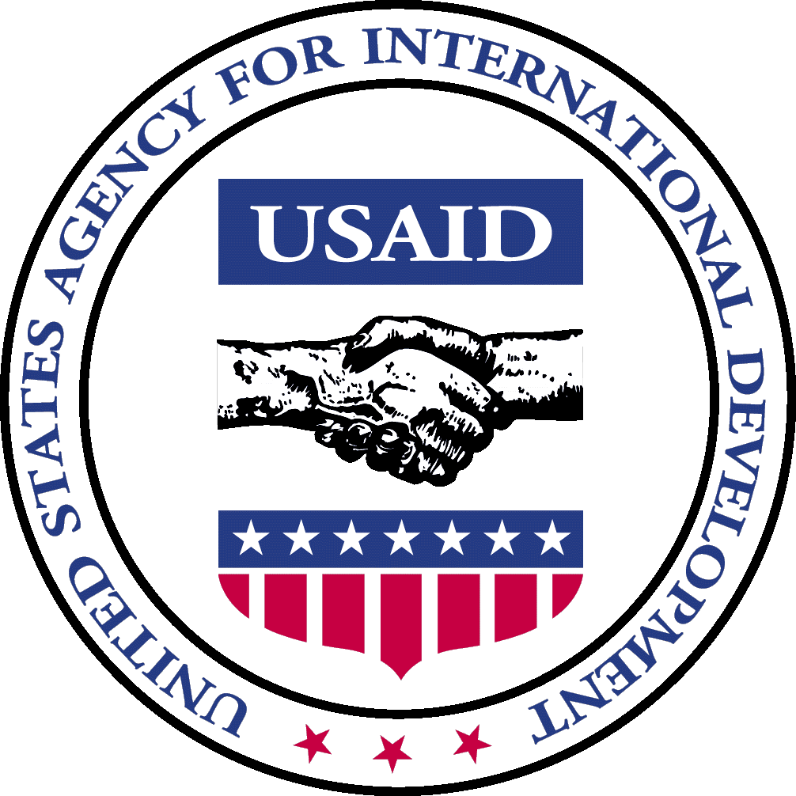

Office of Transition Initiatives
Bureau for Democracy, Conflict and Humanitarian Assistance

United States Agency for International Development

Monthly Report | BURUNDI | September 2004

PROGRAM DESCRIPTION

The Office of Transition Initiatives (OTI) supports the ongoing peace process in Burundi as outlined in the Arusha Peace and Reconciliation Agreement (APRA) by strengthening local capacities to benefit from and contribute to the peace process. PADCO, Inc., the Woodrow Wilson International Center for Scholars (WWICS) and the national NGO African Strategic Impact (ASI) implement OTI’s Community-based Peace and Reconciliation Initiative (CPRI) and manage CPRI’s field offices in the provinces of Gitega and Ruyigi. Through CPRI’s four components: the Community-based Leadership Program (CBLP), vocational skills training (VST), small grants and media, the four organizations encourage local-level cooperation for mutual problem solving, generation of new non-farm income, and dissemination of timely and balanced information that encourages broad participation in discussions related to the peace process. The four organizations work closely with community groups, government entities, media outlets, NGOs, international organizations and other USAID offices to maximize the positive outcomes of their efforts. Since February 2004, OTI has invested $2,493,121 in these activities through one hundred small grants.

COUNTRY SITUATION

Independent Electoral Commission Approved – On September 1, the National Assembly approved five members for Burundi’s National Independent Electoral Commission. They were nominated by President Ndayizeye in consultation with all registered political parties. The Commission received the approval of 178 out of 180 seats in the Assembly, giving it a strong mandate from all the political parties in the Assembly. The U.N. Secretary General’s Special Representative to Burundi, Carolyn McAskie, welcomed the approval of the Commission and offered the assistance of the U.N. Operations in Burundi (UNOB) to ensure free, transparent and democratic elections.

Truth and Reconciliation Committee Created – On August 31, the National Assembly passed legislation to establish a Truth and Reconciliation Committee in line with the Arusha Peace and Reconciliation Accord. President Ndayizeye along with all registered political parties and the National Assembly chose and approved the nominees for the 25-person committee. The National Council for the Defense of Democracy-Forces for the Defense of Democracy (CNDD-FDD) abstained, because the CNDD-FDD, which is not yet officially registered as a political party, was not consulted in the selection of the nominees. The Committee will conduct inquiries into serious acts of violence outside the categories of acts of genocide, war crimes and crimes against humanity that were committed between the establishment of Burundi’s independence in July 1962 and the signing of the Arusha Accord in August 2000. The Committee will also make suggestions to the appropriate government institutions regarding the promotion of reconciliation and forgiveness. UNOB will establish an International Judiciary Inquiry Committee comprised of Burundians and international staff members to look into acts of genocide, war crimes and crimes against humanity.

Ministers Boycott Post-Elections Power-Sharing Agreement – On September 3, President Ndayizeye chaired a Cabinet meeting to approve a draft constitution based on the Pretoria post-election power-sharing agreement signed in August. Vice President Kadege and ten Cabinet members, all members of Union for National Progress (UPRONA) and other predominantly Tutsi parties that were non-signatories to the power-sharing agreement, boycotted the meeting. President Ndayizeye overruled the boycott and submitted the draft to Parliament.

Parliament Adopts Post-Transition Constitution – On September 17, those parliamentarians attending an extraordinary session convened by President Ndayizeye unanimously approved a draft constitution based on the August Pretoria power-sharing agreement. However, three predominantly Tutsi political parties, UPRONA, Social Political Movement-Shield (MSP Inkinzo) and Rally for Democracy, Social and Economic Development (RADDESS), abstained from voting. A national referendum on the draft constitution is scheduled for October 20, 2004.

PROGRAM UPDATE

A. Narrative Summary

In September, OTI approved 29 grants totaling $537,695 bringing the total number of grants approved to 100 and total funds committed in grants to $2,493,121. New grants included generators for OTI and REDSO/ESA media partners to guarantee their uninterrupted broadcasting and support for media outreach, CBLP and VST activities.
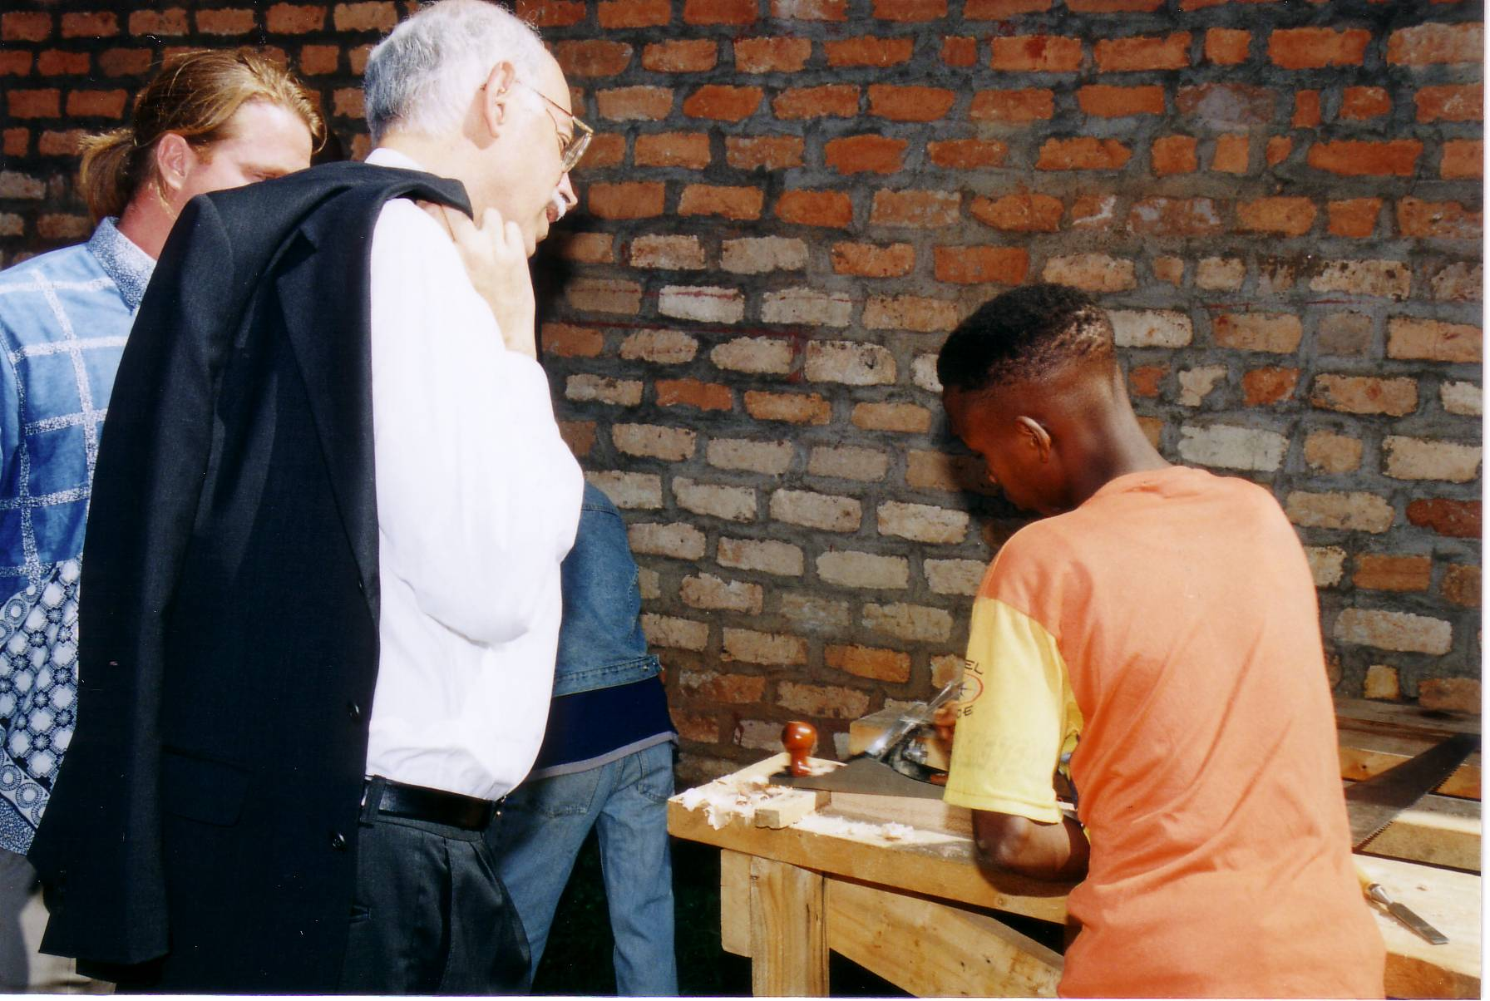
USAID Administrator Andrew Natsios speaks with students at Bwoga Center,
Gitega about their experiences in the VST program.
September’s highlight was a visit to Burundi by USAID Administrator Andrew Natsios, who was accompanied by Africa Bureau Deputy Assistant Administrator Kate Almquist, OTI Director David Taylor, REDSO/ESA Director Andrew Sisson and REDSO/ESA Low-Presence Countries Director Flynn Fuller. U.S. Ambassador James Yellin and USAID Burundi Representatives for REDSO/ESA, OFDA and OTI hosted the delegation. Gitega’s Governor joined them on their Gitega site visit, where they toured CPRI’s vocational skills training school in Bwoga and met with six national and international NGOs providing peace education and leadership training in the province. In a meeting with President Ndayizeye, Administrator Natsios commended CPRI’s vocational skills training program and its inclusion of ex-combatants. Administrator Natsios was also impressed by the strong collaboration among the four CPRI partners: OTI, PADCO, WWICS and ASI, as well as CBLP’s presence in every commune in Gitega and Ruyigi.

In September, OTI Acting Country Representative, PADCO Chief of Party and CPRI’s Media Team met with senior management staff of CPRI media partners: state-owned Burundi National Radio and Television (RTNB) and independent RSF Bonesha FM (Bonesha), to review achievements of the first three-month media outreach campaigns. They also planned outreach activities for October through December, when tensions are expected to remain high due to ongoing political uncertainties. The media team met again with RTNB and Bonesha to analyze the devastating effects of ethnic-based rumors and to discuss possible strategies to effectively counter them. Preliminary feedback from both meetings shows that the CPRI-funded outreach campaigns, which have enabled the two partners to regularly develop programming with Burundians outside the capital, have allowed RTNB to increasingly position itself as a public broadcasting service and Bonesha to reinforce its position as an independent and objective media agency.

In September, CPRI launched the last of four VST schools in Ruyigi. All four VST schools in Gitega opened in July; three other VST schools in Ruyigi opened in August. Students enrolled in VST schools in Gitega completed literacy and numeracy courses and advanced into small enterprise management classes. In this module, students learn basic business skills, including how to analyze material costs and manual labor in order to more accurately price their products. CPRI provides courses in literacy, numeracy and business skills to support future graduates’ income-generating initiatives. Inclusion of graduates of different ethnicities and diverse backgrounds in income-generating associations will help diffuse social tensions and promote ongoing reconciliation.

The VST team held a two-day workshop with directors of VST schools in Gitega and Ruyigi to develop administrative and financial management policies, systems and procedures. Directors learned how to create work plans and calculate future operating costs, which OTI will support through its small grants component. As part of initial efforts to ensure the VST schools’ sustainability, directors also learned how to identify future sources of revenue. The training marks a paradigm shift from schools receiving pre-determined funding levels to schools developing business plans promoting self-management and including projected revenues from the sale of students’ products.

Through CPRI’s community-based small grants, OTI is fostering linkages between community initiatives. For example, program staff arranged for grantee Twungurane Ubumenyi, a women’s basketweaving association, to provide baskets to another grantee, Inamahoro Women’s Association, for use in their theatrical performances promoting reconciliation. Linkages between grantees encourage positive interaction between people from different ethnicities and geographical areas and help communities identify local resources to support their initiatives.

- Grants Activity Summary

Program Category | # of Grants, September 2004 | Funds Obligated, September 2004 | Total # of Grants to Date | Total Funds Obligated To Date
Increased local-level cooperation for mutual problem solving | 21 | $358,250 | 49 | $1,081,034
Generation of new non-farm income by diverse groups | - | - | 26 | $809,317
Public knowledge of political issues increased as a result of media coverage | 8 | $179,445 | 25 | $602,770
Total | 29 | $537,695 | 100 | $2,493,121

- Indicators of Success

In a speech in Nyabitsinda Commune, Ruyigi, the Minister of Interior, accompanied by a senator and the Governor of Ruyigi, thanked the USAID/OTI program CPRI for its tangible contributions to Burundi’s peace and reconciliation process through its small grants. In Nyabitsinda, CPRI has awarded a grant to a women’s basketweaving association that brings together returned refugees and women who remained in Nyabitsinda throughout the conflict.

In all eight VST schools, OTI is on target in enrolling people of diverse backgrounds, thus, creating settings in which conflict mitigation and reconciliation can occur. A total of 870 people are enrolled in masonry, roofing, carpentry, brick and tile making, and sewing courses in the eight schools. Enrollment in the bread making section is currently open with plans to commence the bread making courses within the next few months.

OTI’s support of community initiatives is showing signs of success in bringing people together and fostering positive interactions between local communities and their government leaders. In Gisuru Commune, Ruyigi, recent returnees, local community members and students are working together to rehabilitate Gisuru’s secondary school. Similarly, community participation in the rehabilitation of the Gisuru primary school greatly improved the follow-on meetings, which were organized by program staff and the Governor of Ruyigi to explain to the residents and government authorities the importance of community participation and local ownership.

People participating in the OTI-funded rehabilitation of Mayanza school, Ruyigi, provided positive feedback on their experience of working together on the community initiative. Many people explained that the initiative responds to a need that was causing conflict within the community, while also encouraging positive interaction among community members. One female participant thanked OTI for supporting the community initiative because “now I have friends here on the project”.

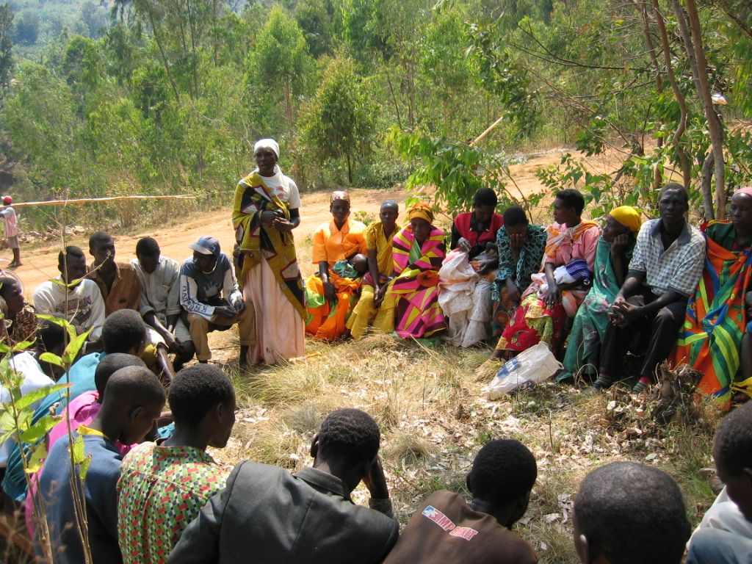
Participants in CPRI’s Community-based Leadership Program (CBLP) are sharing numerous examples of how they are using their newly acquired conflict mitigation skills in their daily lives. In Bukirasazi and Buraza Communes, Gitega, participants are developing an informal forum called Ijwi ry’imboneza or “the voice of community leaders” to systematically exchange their problem-solving and conflict mitigation experiences. The group adopted a motto in Kirundi which means, “We refuse to be spectators [when there is conflict]”.

A hillside chief in Bugendana Commune, Gitega, acknowledged changing his authoritarian attitude following his participation in a CBLP workshop. He admitted that he used to be commanding and would not listen to his constituency. After learning the importance of active listening during the CBLP workshop, he says he has become a more humble leader. As a result, he has gained increased confidence from community members. People resident on his hillside explained that as a result of a change in his leadership style, they are more respectful of him.
A participant in a CBLP training in Bukirasazi Commune, Gitega, shares how she has applied her skills in resolving disputes with her family and neighbors.

In addition, many CBLP participants have applied CBLP skills to solving domestic disputes, which are, according to OTI’s May stakeholder assessment, a primary source of conflict. Through learning about perceptions and active listening, participants explain, they are better able to communicate and constructively interact with their spouses and other family members. Their experiences in applying newly acquired skills demonstrate how CBLP helps people to address their priority problems.

D. Program Appraisal

In September, a VST consultant designed and recommended the adoption of various mechanisms to help ensure the long-term sustainability of the OTI-supported vocational schools. In his debrief, the consultant recommended that the program establish a community steering committee for each school to strengthen community ownership of the schools and thus contribute to the schools’ sustainability. The committees will include representatives of school administration, teachers and students, in addition to local government authorities and community members.

NEXT STEPS/PRIORITIES

In September, the Media team worked closely with media partners RTNB and Bonesha to launch the second media outreach campaign from October to December 2004. The campaign will focus on civic education in anticipation of upcoming elections.

This month, OTI awarded numerous grants for all program areas. During October, the CPRI field team will focus on implementation.

Points of Contact:
In Burundi: OTI Burundi Country Representative, telephone: 257-246-147 or 246-146
In Washington, D.C.: Carlisle J. Levine, Program Manager, e-mail: clevine@usaid.gov , telephone: 202-712-0955

Visit the OTI website at: http://www.usaid.gov Key Word “OTI”

