Brazil’s 2006 Elections

On October 1st, 2006, Brazil will hold presidential, senatorial, and legislative elections.

Brazil has 29 political parties. Four of them have dominated Brazilian politics in recent years; the Workers’ Party (PT), Brazilian Social-Democracy Party (PSDB), Brazilian Democratic Movement Party (PMDB), and Party of the Liberal Front (PFL).

Fernando Henrique Cardoso (PSDB) was elected President in 1994, after the success of his anti-inflation, economic stabilization plan, the Plano Real. In 1997, Congress amended the Constitution to allow for presidential reelections, allowing Fernando Henrique to run again. In 1998, he was reelected with approximately 53 percent of the vote. His closest challenger, Luiz Inácio “Lula” da Silva (PT), garnered about 32 percent.

In 2002, in his fourth bid for president, Lula handily won 61 percent of the vote, to become the 39th and current Presidency of Brazil, on January 1st, 2003. While his labor-union background and radical rhetoric has characterized him as left-wing, he surprised many with his pragmatic move to the center, especially in terms of economic policy. Lula will run again in 2006. His popular support was strongly affected by the “Mensalão” political corruption scandal that struck the government in 2005, involving accusations that the PT financed congressmen with illegal party financial schemes and vote buying. Nevertheless, recent polls reveal that he is the preferred candidate, with Geraldo Alckmin, current Governor of the state of São Paulo, trailing close behind.

The Brazilian Democratic Movement Party (PMDB) is Brazil’s largest political party. It has the majority of seats in the Federal Senate (23 among 81, followed by PFL with 15) and has the second most seats in the Chamber of Deputies (behind the PT), with 85 representatives out of 513. Its large, nationwide representation makes PMDB the best ally for both PT and PSDB. During the two mandates of Fernando Henrique Cardoso, the party was part of the government coalition. In 2002, it shifted sides and threw its support behind Lula, despite its tradition as a centrist party. However, the Mensalão Scandal left the PT’s governing coalition divided, and its alliance with PMDB has deteriorated. In the end of January, the party rejected President Lula’s offer to form an alliance for this year’s presidential election, deciding instead to run its own candidate.

PMDB's main presidential contender was former Rio de Janeiro Governor Anthony Garotinho. However, on May 13th the party voted by 351 votes to 303 not to put forward a candidate for October’s presidential election. The faction of the party which backs Lula overcame opposition elements, who rallied around Garotinho, but the margin of victory was slimmer than had been expected, and there is a chance the PMDB will split down the middle. As has happened before in the party’s recent history, the legality of the meeting will be challenged in a court of law. The decision means that if and when Lula does win re-election, the PMDB will form a key part of his second term’s administration. During Lula’s first term he has been more worried about building a coalition of smaller parties, each of which has required the president to compromise both his policies and his cabinet appointments for the sake of their loyalty in Congress. The likelihood is that Lula will choose his vice-president from the PMDB.

The fourth major player in the current Brazilian political scenario is the Party of the Liberal Front (PFL). In the last legislative elections, of 2002, the party won 84 out of 513 seats in the Chamber of Deputies, and 19 out of 81 seats in the Senate. It is considered to hold right-wing political and economic positions, though it has often engaged in political alliances with centrist and leftist parties with opposing views. It is currently one of the two main opposition parties to Lula’s PT government, together with the PSDB. Before that, it was part of Fernando Herique Cardoso’s government coalition.
Party | Name | Translation | Political Orientation
PT | Partido dos Trabalhadores | Worker's Party | Left
PSDB | Partido da Social-Democracia Brasileira | Brazilian Social Democracy Party | Center
PMDB | Partido do Movimento Democrático Brasileiro | Brazilian Democratic Movement Party | Center
PTB | Partido Trabalhista Brasileiro | Brazilian Labor Party | Center-right
PL | Partido Liberal | Liberal Party | Center-right
PFL | Partido da Frente Liberal | Party of the Liberal Front | Right
PP | Partido Progressista | Progressive Party | Right

Federal Senate Party Distribution

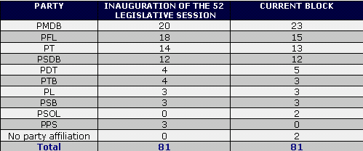

Chamber of Deputies Party Distribution

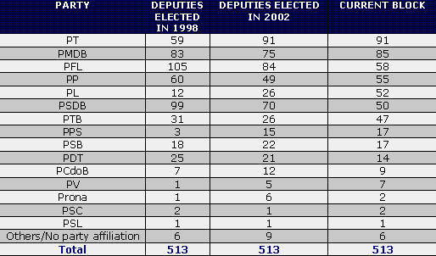

Government Approval Rating
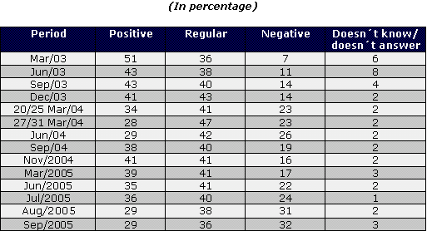
Source: Ibope

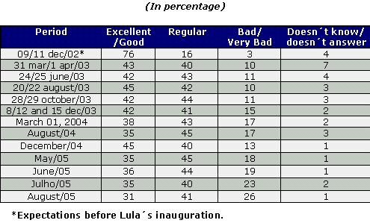
Source: Datafolha

