Millennial Survey Results and Explanations

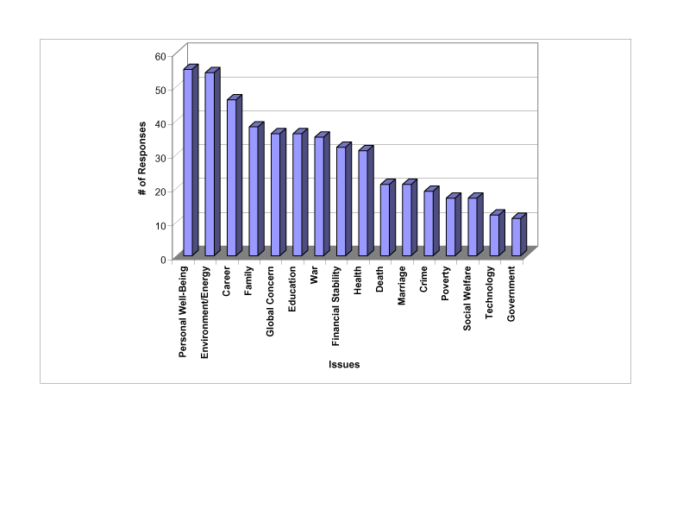
Guide to Reading Graph

These are explanations for the categories that encompassed more than one specific issue. For example, "Poverty" appeared often enough to warrant its own grouping, but many other similarly-natured issues, such as homelessness, did not, and were therefore placed into the appropriate category.
Personal Well-being - Responses such as happiness, success, fulfilling personal goals, settling in the right place, choosing the right path, independence, loneliness, regret, and lack of time are all grouped together in this category.
Environment - Responses in this category are environmental destruction, depletion of natural resources, coping with energy demands, global warming, American over-consumption, the ozone layer, and animal extinction.
Career - Responses in this category include finding a fulfilling job, a well-paying job, and the right kind of job, as well as job security, and achieving success within a chosen career.
Education - This category encompasses all concerns relating to education. These concerns include getting into the right grad school, achieving academic goals, providing education for one's children, and paying off educational loans. Some people also expressed concern about the quality and the future of American schools.
Family - This category includes concerns for the respondent's current family, in particular, the health and safety of family members. It also includes the respondent's concerns about having a family of his/her own.
Financial Stability - It should be noted that this category is linked with the categories of Career, Education, and Personal Well-being. A response was only classified under this category when a respondent specifically expressed concern about financial stability and independence.
Death - This category deals both with a personal fear of death, as well as loss of friends and family.
Global Concerns - This topic includes a concern for a loss of culture and history, globalization, human rights, world hunger, balance of power/American hegemony, political stability, overpopulation, and AIDS.
Social Welfare - This category addresses problems within American society. This category includes concern for quality of life in "digital age," the future of our children, crime, race relations, and homelessness.
Government - This category includes concern for political leadership, government corruption, political apathy, and an unjust judicial system.

