
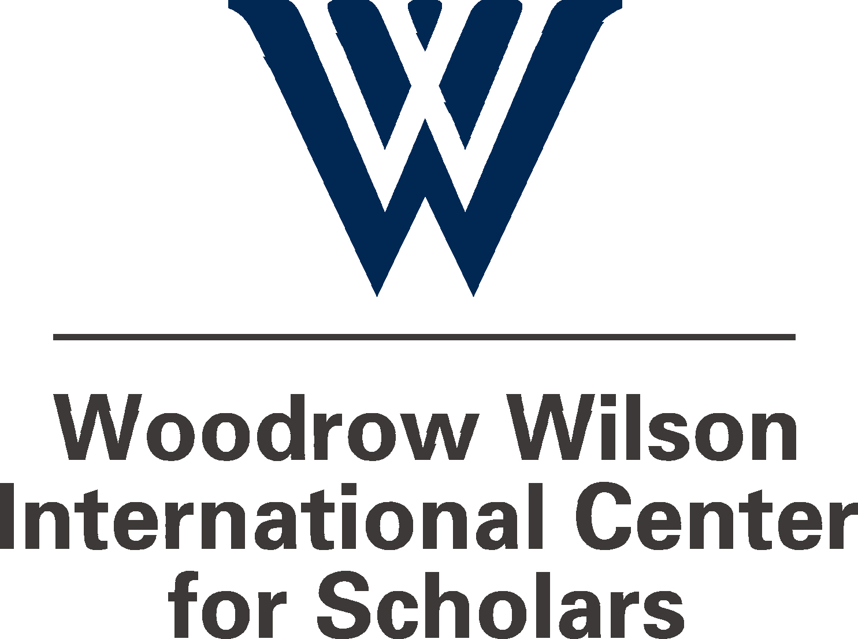


The Impact of Trade Liberalization on Poverty

Friday, April 15, 2005
8:30a.m. – 6:00p.m.

Woodrow Wilson International Center for Scholars
One Woodrow Wilson Plaza, 1300 Pennsylvania Avenue, NW
Washington, DC 20004

Most economists argue that increasing international trade contributes to economic growth and therefore to the alleviation of poverty. Beyond basic questions and theoretical costs and benefits, however, the relationship between trade and poverty becomes considerably more complicated. Even in the most successful cases, the impact of increased trade depends heavily on the condition of existing institutions, public investments in education and infrastructure, the presence of safety nets, and the impact of the world economy. This daylong conference will bring together national and international stakeholders, including economists, policy analysts, policymakers, and business leaders from different parts of the developing world to examine how development and trade liberalization affects poverty.

Conference Agenda:

Session I: The Basic Links between Trade, Growth, and Poverty 8:45 AM - 10:15 AM

This session will review current research on the links between trade, growth, and poverty. The panel will provide different perspectives on these questions and will include voices from both emerging market and least developed countries. This session will briefly assess what current research can and cannot tell us about the impact of trade on poverty.

Chair: Kent Hughes, Director, Program on Science, Technology, America and the
Global Economy, Woodrow Wilson Center

Speakers: Neil McCulloch, Senior Poverty Economist, World Bank Group, Indonesia

Ann Harrison, Professor of Agricultural and Resource Economics,
University of California, Berkeley

Commentator: Bruce Stokes, Trade and International Economics Correspondent, The National Journal

Session II: How the Poor Respond to Opportunity and Adversity 10:30 AM - 12:15 PM

This panel will set the stage for discussion in Sessions III and IV by exploring how poor households respond to trade-related opportunities and challenges such as drops in prices or increases in competition. What conditions affect the poor’s ability to take advantage of opportunities created by trade liberalization such as increased exports or a shift from subsistence to marketable crops? Because the poor are not a homogeneous population, the panel will explore how the impact of trade, coping strategies, and needed policies will vary from one group of poor to another.

Chair: Borany Penh, Political Economist, Poverty Analysis and Social Safety Net Team,
United States Agency for International Development

Panelists: Thomas Hertel, Professor, Purdue University and Visiting Scholar, World Bank Group

William Masters, Professor of Agricultural Economics, Purdue University

Commentator: Caren Grown, Poverty Reduction and Economic Governance Team,
International Center for Research on Women

Luncheon Address: 12:30 PM - 2:00 PM

Poverty Reduction in Context of Development and Trade Liberalization: The Role of Development Cooperation

Keynote Speaker: Sebastian Mallaby, Editorial Writer and Columnist, The Washington Post

Session III: The Contrasting Country Experiences 2:15 PM - 3:45 PM
Panel members will use country studies to understand how complementary investments (education, roads, health, etc.) and policies (effective administration, competitive exchange rates) have influenced the impact of trade liberalization on poverty in Africa, Asia, Latin America and elsewhere.

Chair: William Krist, Senior Policy Scholar, Woodrow Wilson Center

Panelists: Theodore Antwi-Asare, Professor, University of Ghana at Legon

Debapriya Bhattacharya, Executive Director, Centre for Policy Dialogue,
Bangladesh, and Visiting Fulbright Fellow, Center for Global Development

Rebeca Grynspan, Director, United Nations Economic Commission for Latin America
and the Caribbean

Rosario Guzman, Executive Director, IBON Foundation, Philippines

Commentator: Aseema Sinha, Assistant Professor, University of Wisconsin-Madison and
Fellow, Woodrow Wilson Center

Session IV: Challenges for Policymakers 4:00 PM - 5:30 PM

Policymakers in USAID, international financial institutions, and national legislators must apply the lessons drawn from models, statistical analysis, and case studies to current trade negotiations. If, for instance, the Doha Round opened up markets in specific commodities (say cotton, rice, or sugar) how might specific countries respond? What complementary policies, say investments in port facilities or sanitary inspections, would make a difference? How important are improved health and education? Could investments in better roads, the development of an agricultural extension service, and risk limited micro-finance open opportunities for small farmers?

Chair: John Sewell, Senior Scholar, Woodrow Wilson Center

Panelists: Ruth Jacoby, Director-General for Development Cooperation,
Ministry for Foreign Affairs, Sweden

Gawain Kripke, Senior Policy Advisor, Oxfam America

Kamal Malhotra, Senior Advisor on Inclusive Globalisation,
United Nations Development Program

Walter North, Senior Deputy Assistant Administrator, Bureau for Asia and the
Near East, United States Agency for International Development

Support for this conference was generously provided by:
United States Agency for International Development
Office of Poverty Reduction, Poverty Analysis and Social Safety Nets

and

3M Company

Woodrow Wilson International Center for Scholars
One Woodrow Wilson Plaza • 1300 Pennsylvania Avenue, NW • Washington, DC 20004
tel: (202) 691-4000 • fax: (202) 691-4001 • www.wilsoncenter.org

