Building Blocks:
How Schools and Businesses Can Partner to Improve American Education

Speaker Biographies

Wednesday, February 27th, 2008

Keynote Address

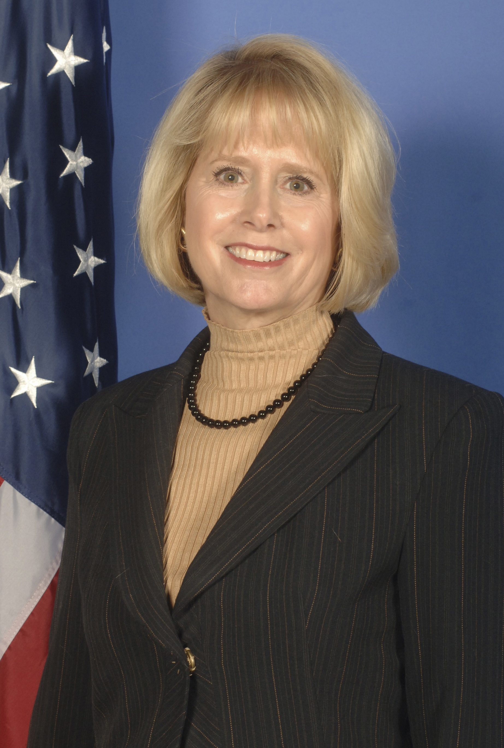
Tyrrell E. Flawn has more than 25 years of experience in nonprofit leadership. Currently, she serves as Executive Director of the National Mathematics Advisory Panel at the U.S. Department of Education. Established by Executive Order in May 2006, the Panel is charged with reviewing the best scientific research and making recommendations to improve mathematics education, with an emphasis on algebra preparation and algebra success. The Final Report will be released in March 2008.

Prior to her work on the panel, she served as executive director of The Children’s Inn at the National Institutes of Health, and, previously, executive director of the RGK Foundation in Austin, Texas, a $110 million family foundation dedicated to medical research, education and community enhancement. Ms. Flawn currently serves on the Women’s Board of the American Heart Association, Greater Washington Region; the advisory board of the Lady Bird Johnson National Wildflower Center; the Departmental Visiting Committee of the School of Human Ecology at The University of Texas at Austin; and the advisory council of the College of Natural Sciences at The University of Texas at Austin. She is a cum laude graduate of The University of Texas at Austin (BS in nutrition) and received an MBA with honors from Rice University.

Session 1 – Business Partnerships and Innovative Methods in Student Learning

Knowledge is Power Program

Allison Fansler currently serves as the President and Chief Operating Officer for KIPP DC, a network of four high-performing college preparatory schools in Washington, D.C. that are part of the national network of Knowledge is Power Program (KIPP) schools. Prior to joining KIPP DC, Ms. Fansler spent three years at the KIPP Foundation, where she advised and trained KIPP principals on business and financial operations. During her tenure at the KIPP Foundation, Ms. Fansler assisted in founding 15 college preparatory charter schools and consulted with an additional 30 charter schools across the country on finance, operations, and governance. Previous to KIPP, Ms. Fansler directed sales and marketing for ThinkWave, Inc., an education software company based in Sausalito, California. She also served in the Clinton Administration as the White House Liaison and Special Assistant to the Chief of Staff for U.S. Treasury Secretary Robert Rubin at the U.S. Department of Treasury, coordinating domestic and international policy initiatives. Ms. Fansler holds a Bachelor of Arts in Spanish from the University of Virginia and a Masters in Business Administration from the Fuqua School of Business at Duke University.

Brittany Lothe, Director of Corporate Citizenship at SAP America, Inc., is responsible for leading citizenship related efforts for SAP in Canada, United States, and Latin America. Program oversight includes internal governance and fiscal reporting, corporate giving, community partnerships, scholarship programs, employee volunteerism and executive involvement. Under Brittany’s leadership, volunteerism has expanded to eleven countries and public-private partnerships have been established in five countries across the region. Prior to this role, Brittany served as Manager for Government Relations where she oversaw the SAP America Political Action Committee (PAC) and grassroots involvement. Under Brittany’s management from 2003 – 2005, the PAC grew by more than 400%. Before joining SAP America in 2003, Brittany served as a Finance Director for Vince Biskupic for Attorney General. From 1998-2002, she has held various campaign and legislative roles in the State of Wisconsin and in Washington, DC. Brittany is committed to civic action. She is a member of the Board of Directors of Knowledge is Power Program (KIPP) DC as well as various non-profit committees including the American Association for People with Disabilities Gala Committee and Suited for Change Gala Committee. In 2007, she co-established and was named trustee of the Lothe Family Endowment and Lothe Family Fund.

Cristo Rey Network

Father Steve Shafran, president of Don Bosco Cristo Rey High School, entered the Salesians of Don Bosco in 1976. He earned a BA in Philosophy in 1979 at Don Bosco College in Newton, NJ; a Baccalaureate in Theology at the Salesian Pontifical University in Rome, Italy in 1983; an MA in Theology from the Pontifical College Josephinum in Columbus, OH in 1985 and a Doctorate in Educational Administration from the University of San Francisco in 1994. He has extensive experience in education and administration in Salesian schools. He arrived in Washington, DC in January 2006 to collaborate with the Archdiocese in establishing this school.

Alicia Bondanella is the Executive Director of the Corporate Work Study Program at Don Bosco Cristo Rey High School. Most recently, Alicia served as a Promotion Specialist at the Catholic Campaign for Human Development (CCHD), the largest private funder of anti-poverty organizations that are directed by low-income people. Alicia developed and coordinated CCHD’s first youth and young adult initiative, including a national paid intern leadership program. She has served in diverse capacities in other educational and non-profit organizations committed to poverty reduction and youth development. Alicia holds a Masters degree in Nonprofit Administration from the University of Notre Dame’s Mendoza College of Business. She earned her bachelor’s degree in Psychology and Religion from the University of San Francisco.

Session 2 – Business Partnerships and Innovative Methods in Student Learning II

NativityMiguel Network of Schools

Joseph Powers currently works as the Headmaster at Washington Jesuit Academy (WJA) in Washington, DC. WJA is a tuition-free middle school for boys that serves an economically disadvantage population. A member of the NativityMiguel Network of Schools, WJA was founded in 2000 by the Jesuit schools and parishes in the Washington, DC area and operate on an extended school day and extended school year model. Powers joined WJA as Headmaster in June of 2007. Prior to working at WJA, he worked as the Assistant Head of School and Middle School Head at Mayfield Junior School in Pasadena, CA and as the Dean of the Resident School at Georgetown Preparatory School in North Bethesda, MD.

Greg Naleski is the Vice-President for Development at the NativityMiguel Network of Schools. The NativityMiguel Network supports 64 middle schools in 27 states. The mission of these middle schools is to break the cycle of poverty through a unique and effective education. The Network is responsible for funding programs, institutes, and conferences that provide professional development for board members, presidents, administrators, and faculty. As the VP, Greg oversees all fundraising, communication, and PR services provided by the Network and within the Network’s office. Prior to coming on board with the NativityMiguel Network of Schools, Greg was the Executive Director for Institutional Advancement at Georgetown Prep and a Major Gifts Officer at Loyola Blakefield.

Project Lead The Way

Niel Tebbano, Vice-President of Operations for Project Lead The Way, Inc., oversees all business aspects of the organization, while contributing to strategy development of all instructional and program components. Tebbano came to PLTW in 2001 after a 32-year career in public education. During that time, he taught and served as principal at the elementary, middle school, and high school levels and oversaw school district transformation as an assistant superintendent for Curriculum and Instruction with the Mohonasen Central School District in upstate New York. In his tenure with PLTW he has led and managed organizational transitions that have triggered and accommodated the growth of the school network to more than 2,000 schools.

Steve Smalley, Advisory Engineer at Northrop Grumman, received his first degree in Computer Science from Penn State University. He has spent the last 25 years working in various aspects of manufacturing. From computer control networks, to advanced robotics, to factory automation, Steve has applied engineering principles to solve real world problems. His second degree was in Systems Engineering to help with integrating factory systems together, as well as working to integrate products to the existing automation systems. Steve has performed extensive cost modeling, led design teams and performed as scheduling manager, all in support of the manufacturing environment. During his time as an engineer Steve has stayed active with many different education programs. He started with Junior Achievement, and has been involved with the local schools ever since. Steve coordinates a network of over 150 engineers at Northrop Grumman, as well as works with the State Board of Education to increase the number of students who are interested in pursuing degrees in technical fields.

Session 3 – Programs to Foster Student Interest in Technology, Science, and Business

FIRST: For Inspiration and Recognition of Science and Technology

Paul Gudonis, President of FIRST, brings 25 years of leadership experience in the information technology and communications industries, as well as a consistent commitment to education. In industry, Gudonis has been a pioneer in wireless, internet, and eLearning software and services. His career has included launching the country’s first cell phone company at Ameritech Mobile; serving as Chairman and CEO of Genuity, Inc., where he grew the first internet backbone network into a billion-dollar global operation; and most recently as President and CEO of Centra Software, Inc., a provider of software for online classrooms and collaboration. In addition to his technology industry experience, Gudonis has taken an active, leadership role in issues such as the impact of technology on society and education. He has served as Chairman of the Massachusetts High Technology Council, and is a member of TechNet, a national organization of technology industry CEOs focused on economic growth and national competitiveness. In addition, he has served on the United Way of Massachusetts Bay Chairman’s Committee and the Dean’s Advisory Council at his alma mater, Northwestern University’s McCormick School of Engineering. He also earned his MBA degree at Harvard University.

Leonard J. Hawkins is the Vice President, Engineering Authority, Customer Solutions Operating Group at BAE Systems, Inc. He oversees the implementation of engineering policy, processes and technical solutions for the BAE Systems Customer Solutions Operating Group and its Lines of Business. Mr. Hawkins joined the company in 2001 and has held prior positions of Vice President, Engineering and Technology, Integrated Systems and Chief Engineer, Systems Integration. Mr. Hawkins has over thirty years of technical and management experience, and has held a variety of senior engineering, management, and consulting positions in the aerospace and defense, and telecom industries. He has managed functional organizations and performed on and directed programs ranging in value from $25M to $10B in national and tactical intelligence, space exploration, space launch, information systems, and commercial aircraft simulation. Mr. Hawkins holds a BS in Quantitative Methods from the University of Santa Clara and an MSSM, Information Systems from the University of Southern California. He has also completed the Executive Course of the Defense Systems Management College.

Make the Connection

Rebecca Patton, Principal at Booz Allen Hamilton, has over 25 years experience managing environmental and installation projects and programs for Federal agencies. Ms. Patton is a technical leader in the Environmental Management Systems, Environmental Outreach, Environmental Liability, and BRAC arenas and works closely with many Navy, DoD, and other Service representatives to shape implementation policy and guidance. Ms. Patton is an active member of her community, serving on the Women’s Advisory Board for the Girl Scout Council of the Nation’s Capital, as a Service Unit Manager and Senior Troop Advisor. She is the Drama Ministries Director for her church and President of the Annandale High School Band Boosters and Director of Concessions. She has one daughter, Jennifer, 17.

Luncheon Address

Susan Traiman is Director of Public Policy at Business Roundtable where she oversees the Roundtable’s work with chief executive officers of leading corporations interested in improving education performance and workforce competitiveness in the United States. Recently cited as “the most influential chief executive lobbying group in the U.S.” by the Financial Times, Business Roundtable members are at the forefront of public policy, advocating for a vigorous, dynamic global economy. Currently the Roundtable, working with fourteen other national business organizations, is leading the “Tapping America’s Potential” campaign to double the number of science, technology, engineering and mathematics graduates with bachelor’s degrees by 2015. Prior to joining Business Roundtable, Ms. Traiman was Education Policies Studies Director at the National Governors Association where she worked with governors on the first National Education Summit and the development of National Education Goals. She also was a senior associate with the U.S. Department of Education's Office of Educational Research and Improvement where she served on the staff of the National Commission on Excellence in Education and contributed to its landmark 1983 report, A Nation at Risk. Before coming to Washington, D.C., she worked at the state level for a regional technical assistance center and at the local level as a seventh grade social studies teacher. Ms. Traiman has a B.A. in American Civilization and M.S. in Education from the University of Pennsylvania.

