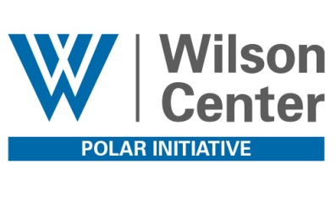
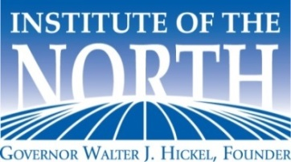

Arctic Economic Development Forum
The Wilson Center, Washington, D.C. Wednesday, 6 April 2016

Hosted by The Wilson Center and Institute of the North, in association with the Senate Arctic Caucus, Arctic Economic Council, Alaska Arctic Council Host Committee and Arctic Parliamentarians.

07.30 AM Registration

08.15 AM Welcome Remarks
- The Honorable Jane Harman, President, Director and CEO, The Wilson Center

Strengthening Partnerships for a Prosperous Arctic Future
Moderated by Laura Dawson, Director, The Wilson Center
- The Honorable Lisa Murkowski, Senator, Alaska, U.S. Congress
- The Honorable Angus King, Senator, Maine, U.S. Congress

09.00 AM Opportunities for and Barriers to Arctic Economic Development
Moderated by Tara Sweeney, Chair, Arctic Economic Council; EVP, ASRC, USA
- Mr. Eero Hokkanen, Arctia Shipping, Finland
- Mr. Haukur Óskarsson, Owner, Refskegg, Ltd.; Icelandic Arctic Chamber of Commerce
- The Honorable Magni Arge, MP, Faroe Islands, Danish Parliament
- Mr. Felix Tschudi, Chairman & Owner, Tschudi Shipping, Norway

10.15 AM Break

10.45 AM Advancing Living and Economic Conditions for Peoples of the North
Moderated by David Biette, Global Fellow, Polar Initiative, The Wilson Center
- Ms. Julie Gourley, Senior Arctic Official, U.S. Department of State
- Ms. Susan Harper, Senior Arctic Official, Global Affairs Canada
- Ms. Else-Berit Eikeland, Senior Arctic Official, Ministry of Foreign Affairs, Norway

Arctic Report
- Ms. Veronica Slajer, North Star Group

12.00 PM Networking Lunch
- Sponsored by Guggenheim Partners

1.00 PM International Arctic Economic Development and Policy
Moderated by Nils Andreassen, Executive Director, Institute of the North
- The Honorable Sjúrður Skaale, MP, Faroe Islands, Danish Parliament
- The Honorable Lisa Murkowski, Senator, Alaska, U.S. Congress

2.00 PM Break

2.30 PM America’s Arctic: Open for Business
Moderated by Ms. Drue Pearce, Crowell & Moring
- Ms. Peggy Philbin, Select USA, U.S. Department of Commerce
- Ms. Gail Schubert, President & CEO, Bering Straits Native Corporation
- Mr. Bill Popp, Anchorage Economic Development Corporation
- Ms. Dana Eidsness, Maine North Atlantic Development Office

3.45 PM Financing Sustainable Development in the Arctic
- Mr. Michael Perkinson, Guggenheim Partners

Concluding Discussion
- Mr. David Biette, The Wilson Center
- Mr. Nils Andreassen, Institute of the North

5.00 PM Adjourn

5:30 PM Bus transportation from The Wilson Center to Norwegian Ambassador’s Residence

6.00 PM Reception – Hosted by the Embassy of Norway
Held at the Norwegian Ambassador’s Residence, 3401 Massachusetts Avenue NW
THANK YOU TO OUR SPONSORS
