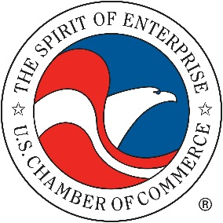
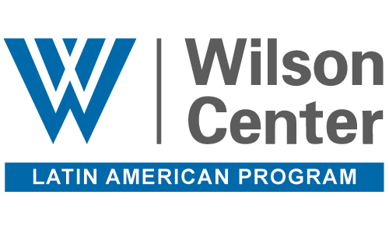

Selecting Guatemala’s Next Attorney General:
What’s at Stake?

Monday, March 5, 2018
3:00 p.m. – 5:00 p.m.
Woodrow Wilson Center
6th Floor Flom Auditorium
Opening Remarks
Dr. Cynthia Arnson is director of the Latin American Program at the Woodrow Wilson Center. She is a widely-recognized expert on Latin American politics, political economy, and international relations, including U.S. policy in the Western Hemisphere. She is co-editor (with Carlos de la Torre) of Latin American Populism in the Twenty-First Century (Johns Hopkins 2013); and editor of In the Wake of War: Democratization and Internal Armed Conflict in Latin America (Stanford, 2012) among other publications. Arnson is a member of the editorial advisory board of Foreign Affairs Latinoamérica, the Spanish-language edition of the distinguished journal Foreign Affairs. She is also a member of the advisory boards of the Social Science Research Council’s Conflict Prevention and Peace Forum, the Salvadoran Foundation for Economic and Social Development (FUSADES), and Human Rights Watch/Americas. She graduated magna cum laude from Wesleyan University, and has a master’s degree and Ph.D. from the Johns Hopkins University, School of Advanced International Studies.
Featured Speakers
Dr. Iván Velásquez Gómez is the Commissioner of the International Commission Against Impunity in Guatemala (CICIG). Before heading CICIG, Dr. Velásquez served as an assistant judge in Colombia’s Supreme Court from 2000 to 2012. During that time, he coordinated the Commission of Investigation Support, where he investigated links between members of Colombia’s Congress and paramilitary groups. The commission’s work has led to the sentencing of approximately 50 members of Congress. From 1997 to 1999, he was the regional director of the Public Prosecution Office of Medellin. In this post, Dr. Velásquez conducted investigations that identified 43 shell companies and 495 bank accounts in the departments of Antioquia and Córdoba that paramilitary groups had used to hold more than 25 billion pesos. He has also served as the Public Prosecutor for the Department of Antioquia and a litigator at and director of the Antioquia Bar Association, COLEGAS. Dr. Velásquez holds a law degree from the Universidad de Antioquia.

Eric L. Olson is Associate Director of the Latin American Program at the Woodrow Wilson International Center for Scholars in Washington, DC. His research and writing have focused on security issues and the impacts of crime, organized crime, and violence on democracies. He has also written about reform of police and judicial institutions as a vehicle for addressing the problem of expanding crime in the Americas. Among his most recent publications are, “Crime and Violence in Central America’s Northern Triangle: How U.S. Policy is Helping, Hurting, and can be Improved.” Prior to joining the Wilson Center he was a Senior Specialist in the Department for Promotion of Good Governance at the Organization of American States. He has also served as Advocacy Director for the Americas at Amnesty International USA; Senior Associate for Mexico, and Economic Policy at the Washington Office on Latin America; and Program Director at Augsburg College’s Center for Global Education in Cuernavaca, Mexico. From 1986 to 1988, he worked in Honduras as a development specialist for several local non-governmental organizations. He has an M.A. in International Affairs from the School of International Service at American University, Washington, D.C.

Marielos Fuentes is the Executive Director of Guatemala Visible, a non-profit dedicated to strengthening Guatemala’s judicial system demanding transparency and accountability of public officials. Guatemala Visible is currently monitoring the selection process for Guatemala’s Attorney General, as well as a number of other selection processes underway in the country. Prior to joining Guatemala Visible, Fuentes served as a communications advisor to the Secretary of Food Security and Nutrition of the Presidency in Guatemala from 2004 to 2005. She was Director of Social Communications for Guatemala’s Ministry of Exterior Relations from 1997 to 2004. She holds a master’s degree in leadership and public management, a degree in public administration from the Universidad Francisco Marroquín, and a bachelor’s degree in communications sciences from Universidad Rafael Landívar.

Úrsula Indacochea is a Senior Program Officer for the Program on Judicial Independence at the Due Process of Law Foundation (DPLF), an organization based in Washington D.C. and dedicated to promoting the rule of law and human rights in Latin America. She previously worked as a legal fellow at the Human Rights Defenders Rapporteurship at the Inter-American Commission on Human Rights. She has served for over 15 years as a litigation attorney, focused on human rights, in the Peruvian high court system. She is co-founder of Constitucionalismo Critico, a non-profit organization that promotes and disseminates critical writing on Constitutional Law. She holds postgraduate degrees from Universidad Carlos III de Madrid and the Pontificia Universidad Católica del Perú.
Moderator
Dr. Anita Isaacs is the Benjamin R. Collins Professor of Social Sciences at Haverford College. Her research focuses on the challenges of peace building and transitional justice in Guatemala. She has been a visiting professor at the University of Pennsylvania, the Facultad Latinoamericano de Ciencias Sociales (FLACSO) in Guatemala City, and a visiting scholar at New York University’s Center for Latin American and Caribbean Studies. In addition to teaching, she has consulted on corruption and organized crime in Central America for the U.S. Department of State, Freedom House, and a number of newspapers and magazines including the New York Times and New Yorker. Dr. Isaacs holds a D.Phil. in Politics and an M.Phil in Latin American Studies from Oxford University and a first class honors B.A. in Political Science from McGill University.
Closing Remarks
Kendra L. Gaither serves as the Executive Director for the U.S.-Colombia Business Council. She joined the U.S. Chamber of Commerce in 2015 as senior director for policy in the Americas. She leads the Chamber’s Coalition for the Rule of Law in Global Markets initiative. She joined the Chamber from Carnegie Mellon University, where she was a global initiatives adviser in the College of Engineering and executive director of the Center for International Policy and Innovation. An alumna of the Thomas R. Pickering Foreign Affairs Fellowship, Gaither began her career in international affairs at the U.S. Department of State. There she spent more than 10 years as a career diplomat and civil servant specialized in international economic and trade issues in Latin America and Sub-Saharan Africa. Gaither holds a B.S. in economics from North Carolina A&T State University, as well as an M.A. in international affairs and an M.B.A. in international business finance from The George Washington University.

